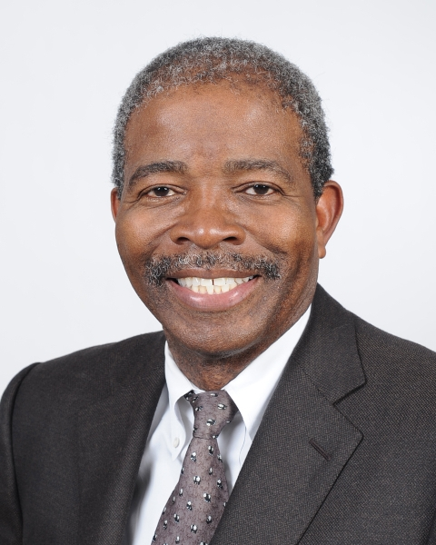
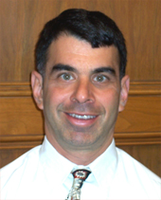
RONALD L. BROWN, PUBLIC DEFENDER
Ronald L. Brown was sworn in as the Public Defender of Los Angeles County on January 5, 2011. Mr. Brown is the first African-American to head Los Angeles County’s Public Defender’s office and is only the 10th person to head the Los Angeles County Public Defender’s Office, which opened its doors in 1914 as the nation’s first publicly funded indigent criminal defense agency. He leads a staff of more than seven hundred licensed attorneys plus a support staff of paralegals, investigators, social workers, and secretaries, all dedicated to the representation of indigent clients. The Public Defender represents adults who have been accused of felony or misdemeanor crimes, juveniles facing delinquency proceedings, involuntarily detained mental health patients, and persons with appellate and limited civil contempt matters.
Ron was born in Ogden, Utah, but was raised in Watts, Willowbrook, and Compton, where he graduated from Centennial High School. He was one of ten children supported by food stamps and other public assistance. Ron refused to be burdened by poverty but instead aimed high and obtained the first-class education he knew he would need to be a success in life. Ron received his undergraduate degree from USC in History in 1976 and his Juris Doctor from UCLA in 1979.
Mr. Brown’s most recent assignment before his promotion to Public Defender was Assistant Public Defender for Branch and Area Operations. Ron regularly attends management training programs, and his abilities have been recognized through his receipt of a variety of awards and commendations including a certificate of commendation from retired Supervisor Yvonne Brathwaite Burke.
Ron is a 25-year resident of Long Beach and currently resides in Bixby Knolls with his wife Kathleen Bursley.

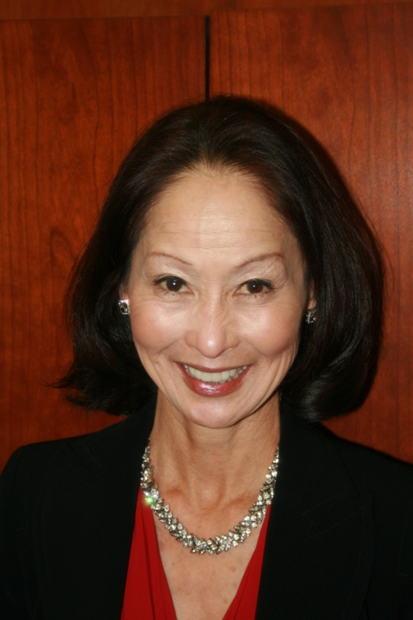
JANICE Y. FUKAI, ALTERNATE PUBLIC DEFENDER
Janice Y. Fukai is the Alternate Public Defender (APD) and the first Asian American woman to serve as Department Head in Los Angeles County’s history. Upon her unanimous appointment, the Board of Supervisors praised her appointment stating: “The current APD Chief Deputy Janice Fukai has been instrumental in the development and leadership of the Department. The entire Board has a lot of confidence in that office and her in particular.”
After receiving her Bachelors and Juris Doctor Degrees from USC, Ms. Fukai served as a Judicial Law Clerk for the late Robert M. Takasugi, Federal District Court Judge, whom she describes as her mentor and advisor throughout her career. She joined the County Family in 1980 with the Public Defender where she rose through the ranks to Senior Trial Deputy and Special Assistant to former Public Defender, Wilbur F. Littlefield. Her work as a trial attorney is featured in a book “Public Defender, Lawyer for the People” by Joan Hewitt.
In 1993, the Board of Supervisors created the new department of Alternate Public Defender (APD) to handle Public Defender conflict of interest cases. After what Ms. Fukai describes as “13 outstanding years with the Public Defender,” she transferred to the APD as that department’s first Chief Deputy and for the challenge of building a new county department, literally “from scratch.” Ms. Fukai is quick to credit the success of her department to her staff comprised of 300 lawyers, investigators, paralegals, clerical and administrative support personnel. “Being with the department since day #1, I have had the unique opportunity of hiring every member of the APD family. They are the real heroes. I am eternally grateful and loyal to them.
DR. MITCHELL H. KATZ, DIRECTOR OF HEALTH SERVICES
Dr. Katz has an extensive background in the field of public healthcare and executive-level healthcare management. He has more than 19 years of experience with the City and County of San Francisco Department of Public Health, and has been serving as the director of public health/health officer since 1997. In this capacity, he is responsible for an operating budget of $1.5 billion and a large healthcare system that includes two hospitals, nine primary care health centers, the County's managed care mental health system, and 8,600 employees.
Among his accomplishments include designing and implementing “Healthy San Francisco,” a comprehensive health care coverage program serving more than 53,000 uninsured San Franciscans through a public-private partnership. The program won the National Association of Public Hospital Chair’s Award (highest award given, 2010) and American Hospital Association NOVA Award (2010).
Dr. Katz grew up in Brooklyn, graduated from Yale and Harvard Medical School. He did his residency at the University of California, San Francisco.
On January 3, 2011, the Los Angeles County Board of Supervisors appointed Dr. Mitchell H. Katz to head the Department of Health Services (DHS).
“While Dr. Katz has experience in running a major urban public health care system, he also has the vision and passion to steer the L.A. County Department of Health Services to meet the challenges and opportunities posed by national health reform,” said Supervisor Zev Yaroslavsky.
“L.A. County is fortunate to have such an accomplished leader join our team,” said William T. Fujioka, County chief executive officer. “His proven experience in the public healthcare field brings vision and knowledge to our health system.”

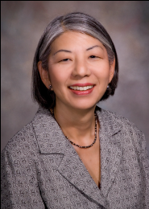
CAROLYN F. RHEE, CEO - VALLEYCARE NETWORK
Carolyn F. Rhee currently serves as the Chief Executive Officer (CEO) for a Network consisting of Olive View-UCLA Medical Center, High Desert Multi-Service Ambulatory Care Center, Mid-valley Comprehensive Health Center, and seven Health Centers. Her budget is $511 million with 13,961 admissions and 476,672 visits annually. She was responsible for eliminating a budget deficit in a one year period.
After receiving her Bachelor of Science in Business Administration and Master of Public Administration from USC, she began her career as an Administrative Assistant in 1979 at Los Angeles County + USC Medical Center and gradually moved up the ranks at various health facilities as a Health Systems Planner, Budget Analyst, Assistant Hospital Administrator, Associate Hospital Administrator II, Acting Hospital Administrator II, and Project Director prior to becoming CEO of the ValleyCare Network.
Ms. Rhee is a member of the Asian Health Care Leaders Association, American College of Health Care Executives (ACHE), Healthcare Executives, USC General Alumni Association and Health Services Alumni Association, and Los Angeles County Asian American Employees Association.
She is very active as a volunteer and has held various executive positions in various organizations. As a result of her countless hours of volunteer work, Ms. Rhee was awarded the Lifetime Achievement Award and Volunteer of the Year Award from the American Cancer Society, San Fernando Valley Unit.

